 PROJECT REPORT TEMPLATE

1. **INTRODUCTION:**

1.1 Overview:

We present a concept of URBENAURA, an urban personal projection to initiate the communication. In this work, we focus on how to break the ice with strangers through technology in urban public space. The Aura, as an enliven spiritual pet, floats around user's feet. We introduce a simple interaction scenario, attracting a person who comes within personal distance of the user who carries the AURA. To break the ice between strangers, a projected butterfly as the Aura is moved toward a person who comes within 2m of the user, and then back and forth to attract that person. We believe that externalized interactive representation of the user in the form of a spiritual pet can ease and facilitate the communication, serve as a conversation starter, and make the interactions between people more fun.

1.2 Purpose:

organically created to radiate high, positive frequencies and encourage conscious, healthier decisions in the community. Our goal is to help people overcome adversity, heal their aura, and improve their overall quality of life.

1. **Problem Definition & Design Thinking:**
   1. 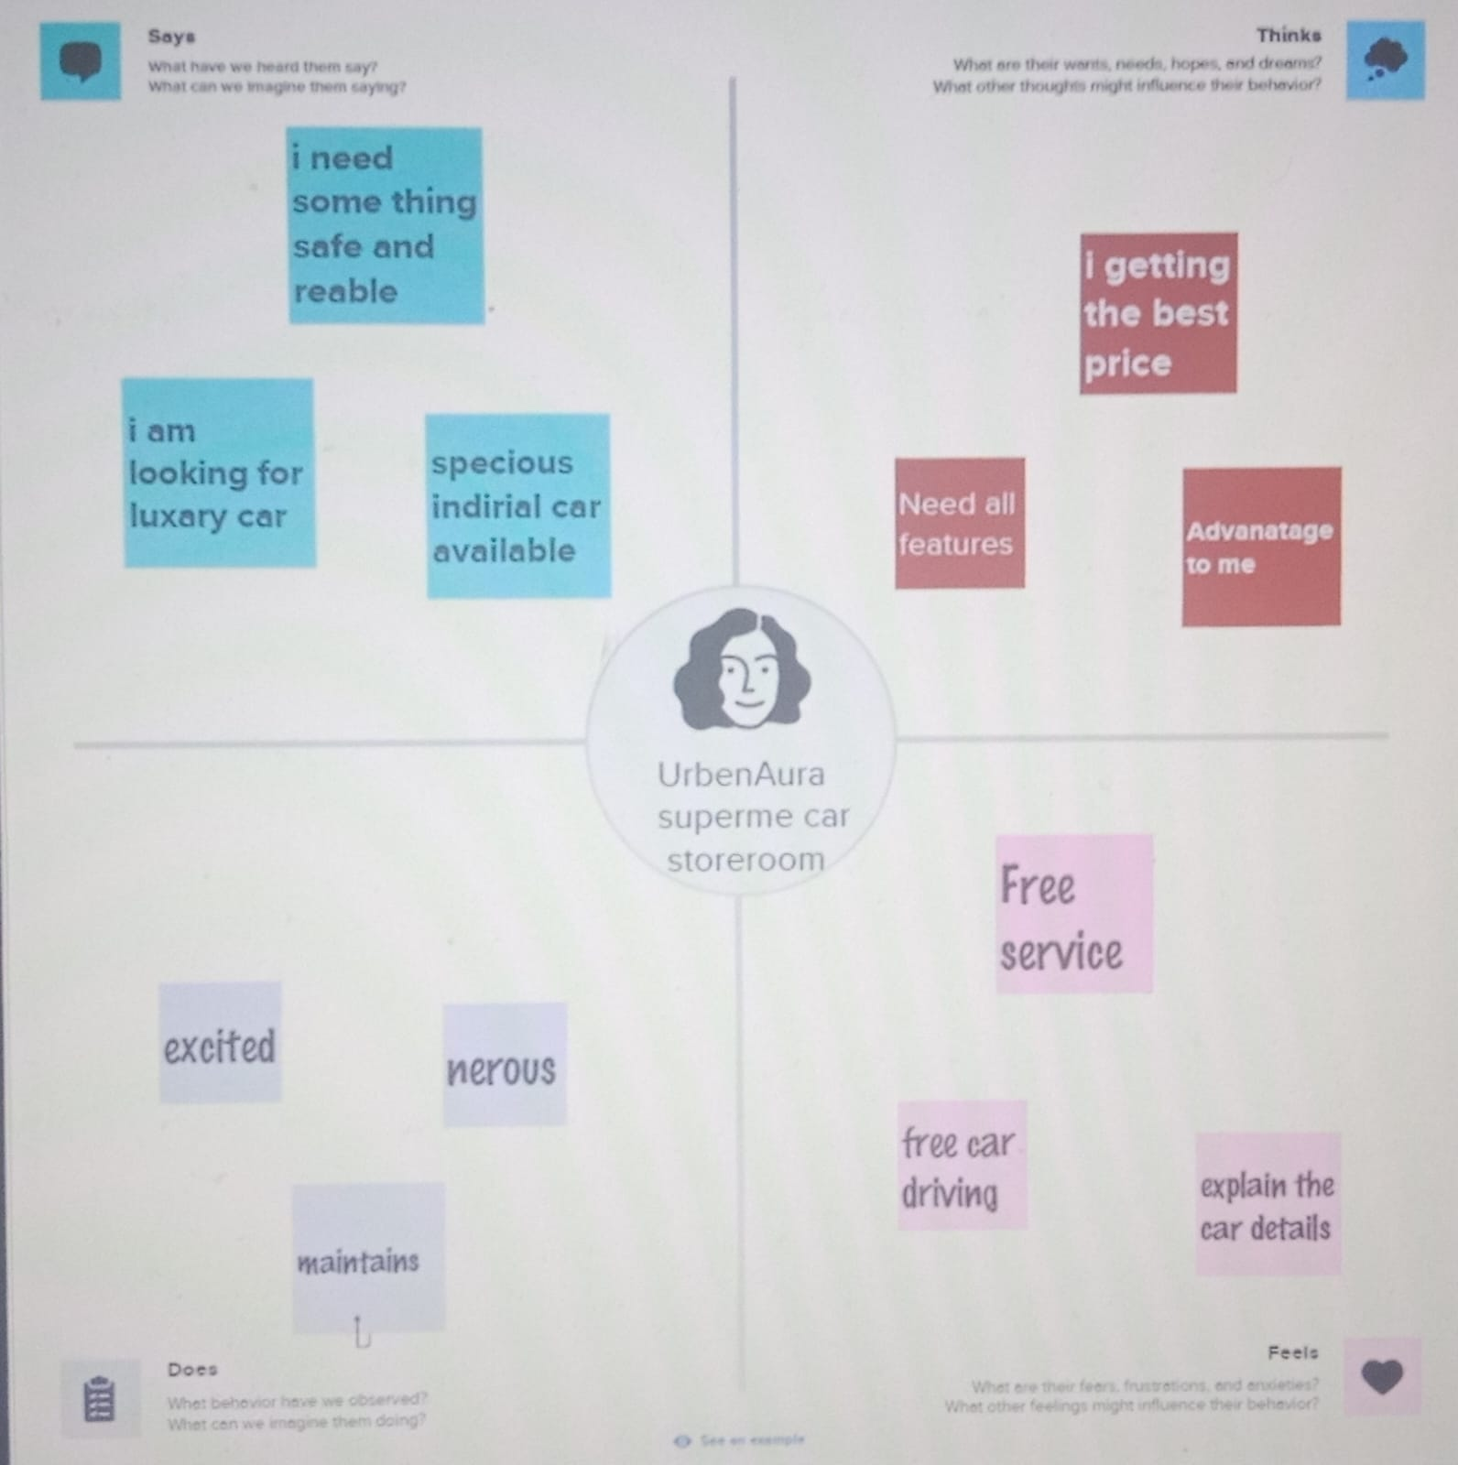empathy map:
   2. 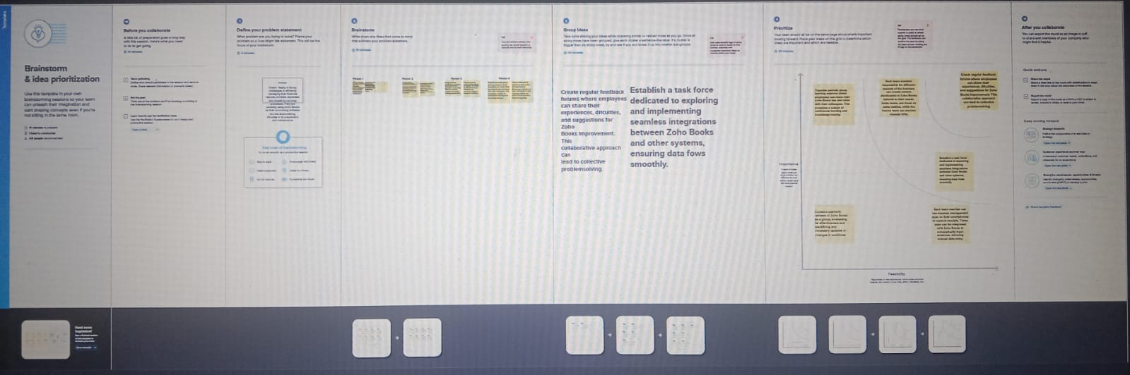 Ideation & Brainstorming Map:
2. **RESULT:**

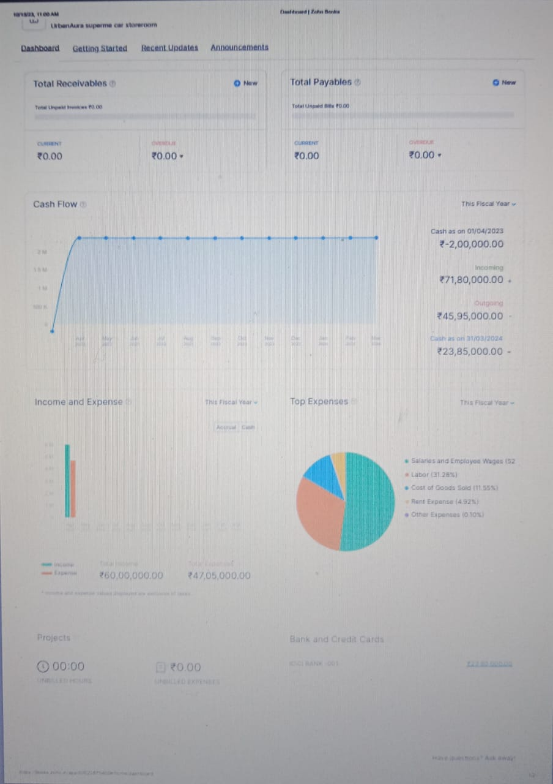

1. **ADVANTAGES:**

**Expertise:**

* Urban interior designers often have specialized knowledge of maximizing small or unique spaces commonly found in urban settings.

**Aesthetics:**

* They can create stylish and modern designs that align with urban aesthetics, which can be particularly appealing to urban clients.

**Space Efficiency:**

* Urban interior designers can help maximize the use of limited space and storage solutions in compact urban dwellings.

**Personalization:**

These services can be tailored to the client's specific preferences and lifestyle, creating a unique urban living environment.

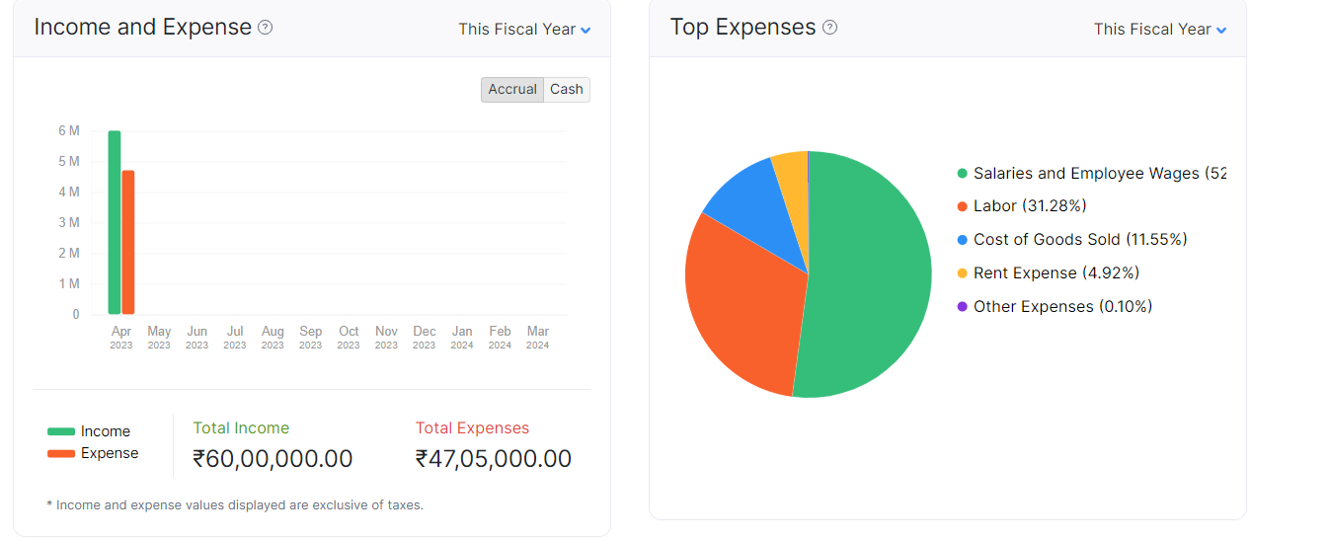

Disadvantage:

**Cost:**

* Hiring professional interior designers can be expensive, and urban design services might come at a premium due to the specific challenges of urban living spaces.

**Limited Space:**

* Working within the constraints of urban environments can be challenging, and some design ideas may not be feasible.

**Regulatory Hurdles:**

* Urban areas often have strict building codes and regulations that can limit the scope of design changes and renovations

**5.APPLICATION:**

**Residential Interior Design:**

* Transforming the interior of urban apartments or houses to make them more functional, stylish, and comfortable.
* Creating customized design solutions to maximize limited space in urban homes.
* Integrating modern design elements that suit the urban lifestyle.

**Commercial Interior Design:**

* Designing and decorating commercial spaces such as restaurants, retail stores, offices, and boutiques in urban areas to attract customers and create a unique brand identity.

Adhering to specific industry requirements and compliance while enhancing the aesthetics and functionality of the space.

**PROJECT FLOW:** 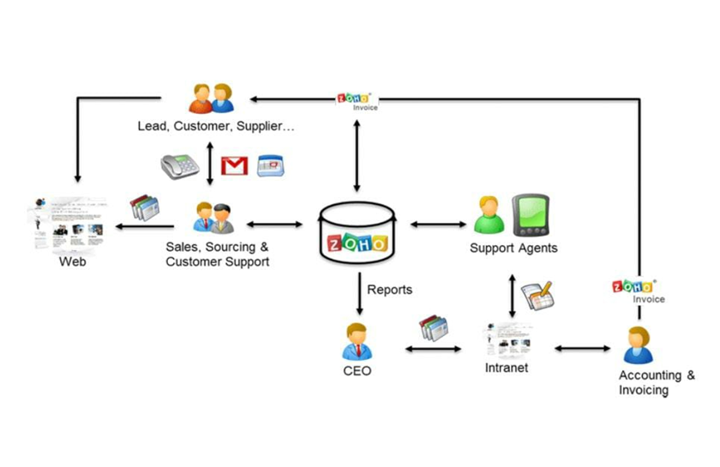

**GOOD INTERIOR DESIGNING:**

* The world's recent shift towards prioritizing wellness has influenced people to seek healthier lifestyles by understanding the body and the mind collectively. External factors such as the geographic location, the environment, the community, financial status, and the relationships with friends and family have all shown to have considerable impacts on an individual's health.
* However, it became evident that ensuring physical and mental health was not limited to having access to medical facilities and professional treatments, but was also determined by several factors related to the quality of the built environment.
* ARCHITECTS HAVE A CHOICE TO DESIGN BETTER AND CONSEQUENTLY , HELP , PEOPLE MAKEBETTER CHOICES. So what is considered a good interior design, and what are the factors that make any interior space a good one? In this interior focus, we will explore this "good" side of design, looking at how architects ensured the needs of users by acknowledging accessibility, demographic diversity, economy, and the environment, regardless of aesthetic.

**OBJECTIVES :**

* Establish A Comprehensive Spatial Development Framework And A Set Of Development Policvies.
* A Direct Response To People’s Need And Creating A Livable Environment . It Covers All Dimensions Like Visuals,Perceptual,Social,Cultural,Historicaland Symbolic Resoures Of Community.
* Increase The Functional Efficieny By Relating The Circulation , Urban Activities And Use Of Land Of Physical Form.
* Accomodating Urban Growth And Should Be Capable Of Adapting Variables Of Unpredicted Growth .
* Economically Feasible Solutions , Geared To Incremental Implementation Over A Substantial Time Period.
* Solving The Environmental Defficieny That Existing In Terms Of Physical,Visual,Perceptual,Social And Pyscological Terms.

**STEPS TO CREATE AND MAINTAIN ACCOUNTS FOR URBAN AURA INTERIORS IN ZOHO BOOKS:**

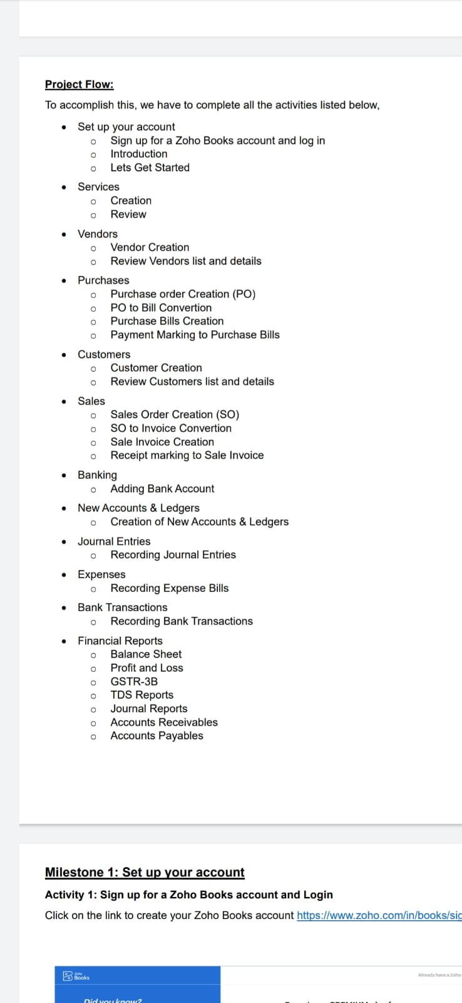

**6 .CONCLUSION:**

**TO CONCLUDE THE OVERVIEW OF URBAN AURA INTERIORS:**

* URBAN AURA INTERIORS STANDS AS A TESTAMENT TO CREATIVITY,INNOVATION,AND UNWAVERING DEDICATION TO TRANSFORMING INTERIOR SPACES INTO REMARKABLE AND FUNCTIONAL WORKS OF ART.
* WITH A COMMITMENT TO MERGING AESTHETICS AND FUNCTIONALITY , OUR MISSSION IS TO INSPIRE AND DELITE,CREATINGH DESIGNS THAT REFLECT OUR CLIENT’S UNIQUE PERSONALITIES WHILE OPTIMISING COMFORT AND UTILITITY .

**7. FUTURE SCOPE:**

**Zoho Books is a constantly evolving software, and new features are being added all the time. Here are some possible future enhancements that could benefit HealthHub Medical Clinic:**

**Integrated patient portal: A patient portal would allow patients to view their account balances, pay their bills, and schedule appointments online. This would help to reduce the administrative workload for clinic staff and improve the patient experience.**